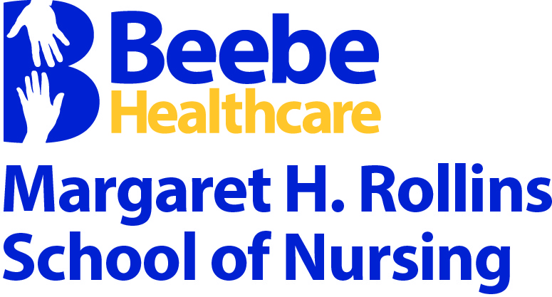

Campus Crime & Fire Safety Report & Safety/Security Policies

2021-2022 Academic Year
Margaret H. Rollins School of Nursing
Campus Crime & Fire Safety Report & Safety/Security Policies

Table of Contents
 | Page
Introduction | 3
Campus Crime | 3
The Security Department | 3-4
emergency notification and safety tips | 4-5
timely warnings | 5
Confidentiality | 5
Annual campus safety and crime statistics: | 6-7
Arrests | 6
Disciplinary Actions | 6
Criminal Offenses  Vawa Offenses | 6-7  7
Safety, crime awareness & campus security policy | 8-13
Evacuation plans  Information Security – Cybersecurity | 14-16  17-22
sexual harassment & other forms of harassment policy | 23-25
drug and alcohol policy | 26-28
workplace violence prevention policy – beebe healthcare | 29-37

INTRODUCTION
CAMPUS CRIME
In order to comply with the Jeanne Clery Disclosure of Campus Security Policy and Crime Statistics Act, School of Nursing Administration prepares this annual report with campus crime/fire safety, policies, procedures and three years of crime statistics provided by the Beebe Healthcare Security Department located on the Margaret H. Rollins Lewes Campus. The full text of this report can also be located on the SON website for use by prospective students. Each academic year, the Campus Crime & Fire Safety Report is distributed to students, faculty and staff, who all must acknowledge that the School has provided them with campus crime and fire safety information in compliance with the Clery Act and that they have read the information. The SON will report crimes in the Annual Report of domestic violence, dating violence, and stalking, as well as the total number of crimes that were “unfounded” (determined by a sworn or commissioned law enforcement officer to be false or baseless) and gender identity and national origin as two new categories of bias for a determination of a hate crime. The Margaret H. Rollins School of Nursing is located on the main campus of Beebe Healthcare which is located in the town of Lewes, Delaware. The Beebe Healthcare Security Department is committed to providing a safe and secure environment for all members of the campus community, including the SON. Unfortunately, because there are no risk-free environments, crimes do occur. To assist in the prevention of crimes and/or serious incidents, faculty, hospital staff, trained security officers and students share the responsibility for their own safety and security. Margaret H. Rollins School of Nursing understands the role of security and is committed to supporting this endeavor by developing programs that support an environment of well-being for the activities of its students, employees, visitors and patients. The term “campus” refers to all Hospital and Margaret H. Rollins School of Nursing (SON) properties, as well as the public property within and adjacent to the Margaret H. Rollins Lewes campus. There are no non-campus properties in use for student housing or remote classrooms. The Margaret H. Rollins School of Nursing does not provide any student residence.
THE SECURITY DEPARTMENT
The Hospital employs a full-time, in-house Security Department which provides around-the clock protection and services. The Department of Public Safety and Security (DPSS) is responsible to assist with the implementation and enforcement of the security management program and other specified activities as per the departmental polices. DPSS is also responsible for responding to and taking appropriate action in the event of criminal activity, fire, potential hazardous incidents, and other emergencies. Foot and vehicular patrols are also conducted 24 hours a day throughout the year. The department has security officers led by the Director of Safety and Security. Security officers are on duty on the Hospital’s property and the School of Nursing campus, which includes the classroom areas, laboratories, and the outside perimeters adjacent to the campus. Beebe Healthcare’s security officers have the authority to ask persons for identification and to determine whether individuals have lawful business at the SON. Criminal incidents are referred to the Lewes Police Department or Delaware State Police who have jurisdiction on the campus. The Security Department reports all criminal incidents occurring on the campus to the appropriate federal, state, and/or local police agency. This cooperative team approach addresses situations as they arise as well as future concerns.

Students and Employees should report Clery Act crimes to the Director of Safety & Security and/or to the Director of the School of Nursing
- Director of Beebe Healthcare Safety & Security: Frank Molino, 302-645-3533
- Margaret H. Rollins School of Nursing Director: Dr. Karen Pickard, 302-645-3251

In addition to security and emergency procedure responsibilities, the Security Department provides a number of support services for the needs of the campus community. Some of those services include:
- Maintain a high visible security presence throughout the hospital on all shifts.
- Patrol the hospital buildings and property to identify and document potential or actual problems.
- Take appropriate and timely action to prevent crime, injury, or property loss.
- Provide timely response to emergencies and requests for assistance. Report crime, fire, injury, or other incidents.
- Communicate externally with local, state, or federal law enforcement and other civil authorities.
- Provide internal communications as needed.
- Document Department of Public Safety & Security activity; including investigations, routine patrol activity, special and routine request for assistance, and other activities.
- Provide timely response to reports of violent activity or requests for assistance in de-escalating or restraining violent or aggressive patients or visitors.
- Develop and maintain access control systems for all entrances of the facility.
- Conduct a risk assessment of the Labor and Delivery Unit and Pediatric Unit to identify areas of concern for infant and pediatric abductions. Conduct Code Pink and Code Adam drills.
- Provide daily twenty-four (24) security coverage in the Emergency Department.
- Establish and maintain security policies and procedures to direct staff performance when responding to security incidents.
- Maintain safety and security policies, as well as Environment of Care Management Plans and the organization’s emergency operations plan.
- Maintain Safety Data Sheets (SDS) for Hazardous Materials.
- Control vehicle movement on hospital grounds, including control of parking and access to the Emergency Department.
EMERGENCY NOTIFICATION AND SAFETY TIPS
A representative of the Hospital’s Security Department meets with the incoming class during orientation to discuss and answer questions about the School’s security policies and procedures, to encourage students to be responsible for their own security and the security of others, and also to inform students about methods to prevent crime. The Everbridge Emergency Notification System is explained, and students are registered for notifications, usually by text messaging on cell phones. The Security Department is available to conduct additional, specific crime prevention programs, in such areas as prevention of crimes of theft, assault, and sex offenses such as date rape.
While at the School, or out in the community, students should practice some of these personal safety tips for the protection of themselves and others:
- Never prop exit doors open at the School of Nursing. This only serves as an invitation to unwanted visitors and may result in harm to yourself or others.
- Keep your locker secured when unattended.
- Avoid walking alone at night. Walk with a friend to and from cars, to and from the Hospital, or around town. Security Escort Service is available anytime students wish to have an escort to and/or from a campus destination. To access the service, students dial Ext. 3533 from the in-house phone system.
- Have your keys or I.D. Badge ready upon approach to your car or the school.
- Avoid poorly lit and isolated areas.
- Avoid wearing headphones or earbuds while walking or jogging; tune in to surroundings.
- Secure purse under arm.
- Report any suspicious individuals on School property or loitering outside the School or in the parking areas.
- Always carry some form of personal identification.
- Be aware of controlling behavior when dating (i.e. intimidating stares, degrading jokes, extreme jealousy, and possessiveness)
- Remember that crime can happen to any of us, so be careful, not regretful.
TIMELY WARNINGS
If a crime or series of crimes have occurred on campus or close to campus and could be considered a threat to other students, employees, and faculty, Beebe Healthcare may implement a “Security Timely Warning Alert.” The Director of Safety & Security or designee is responsible for making the decision to initiate and prepare the alerts after consultation with the Program Administrator of the School of Nursing. The dissemination of information may be accomplished through the distribution of an authorized alert announcement via e-mail, text message, Edvance360 Learning Management System, or other forms of electronic communication. Through these alerts, members of the campus community are provided with prompt notices of incidents that may have a direct impact on their safety and security. The Hospital uses coded emergency announcements (bomb threats, fire, etc.), which can be found on the Hospital’s Intranet page under the Policy and Procedure Manual listing of “Emergency and After Hours Medical Codes” and/or “Emergency Operations Plans – Section 3”.
CONFIDENTIALITY
Violence Against Women Act (VAWA) Section 3, 42 USC §13925(b)(2)(2008) became effective in 2006 and protects the confidentiality of anyone who requests or receives services for a domestic violence, sexual assault, dating violence or stalking incident. VAWA prohibits disclosure of personally identifying information or individual information collected in connection with services requested, utilized, or denied, unless Beebe Healthcare gets the informed, written, reasonably time‐limited consent of the individual. The SON will not include personally identifying information about the victim in Margaret H. Rollins School of Nursing’s disclosure of crime statistics. Margaret H. Rollins SON will maintain confidentiality of any accommodations or protective measures given to the victim.

ANNUAL CAMPUS SAFETY CRIME STATISTICS
Arrests:  On-Campus | 2018 | 2019 | 2020
Weapons: Carrying, Possessing, etc.- | 0 | 0 | 0
Drug Abuse Violations- | 0 | 0 | 0
Liquor Law Violations- | 0 | 0 | 0

Arrests:  public property | 2018 | 2019 | 2020
Weapons: Carrying, Possessing, etc.- | 0 | 0 | 0
Drug Abuse Violations- | 0 | 0 | 0
Liquor Law Violations- | 0 | 0 | 0

Disciplinary Actions: On-Campus | 2018 | 2019 | 2020
Weapons: Carrying, Possessing, etc.- | 0 | 0 | 0
Drug Abuse Violations- | 0 | 0 | 0
Liquor Law Violations- | 0 | 0 | 0

Disciplinary Actions: public property | 2018 | 2019 | 2020
Weapons: Carrying, Possessing, etc.- | 0 | 0 | 0
Drug Abuse Violations- | 0 | 0 | 0
Liquor Law Violations- | 0 | 0 | 0
Criminal Offenses:  On-Campus | 2018 | 2019 | 2020
Murder/Non-negligent manslaughter | 0 | 0 | 0
Negligent manslaughter | 0 | 0 | 0
Rape | 0 | 0 | 0
Fondling | 0 | 0 | 0
Incest | 0 | 0 | 0
Statutory rape | 0 | 0 | 0
Robbery | 2 | 0 | 0
Aggravated assault | 4 | 0 | 0
Burglary | 0 | 0 | 0
Motor vehicle theft | 0 | 0 | 0
Arson | 0 | 0 | 0

Criminal Offenses:  pUBLIC pROPERTY | 2018 | 2019 | 2020
Murder/Non-negligent manslaughter- | 0 | 0 | 0
Negligent manslaughter- | 0 | 0 | 0
Rape | 0 | 0 | 0
Fondling | 0 | 0 | 0
Incest | 0 | 0 | 0
Statutory rape | 0 | 0 | 0
Robbery | 0 | 0 | 0
Aggravated assault | 0 | 0 | 0
Burglary | 0 | 0 | 0
Motor vehicle theft- | 0 | 0 | 0
Arson | 0 | 0 | 0

VAWA Offenses:  On-Campus | 2018 | 2019 | 2020
Domestic Violence- | 0 | 0 | 0
Dating Violence- | 0 | 0 | 0
Stalking - | 0 | 0 | 0

VAWA Offenses:  public property | 2018 | 2019 | 2020
Domestic Violence- | 0 | 0 | 0
Dating Violence- | 0 | 0 | 0
Stalking - | 0 | 0 | 0

* Campus Crime Statistics are maintained by the Department of Safety & Security at Beebe Healthcare. Detailed records are available on-site for review as needed.
* No criminal offenses to report, therefore no data disaggregated according to bias.
* Updated definition of “campus geography” in 2021 (pg.3). However, due to the COVID pandemic there were no visitors on campus.
Beebe Healthcare
Margaret H. Rollins School of Nursing

Academic & Administrative Policy
Safety, Crime Awareness & Campus Security

Value: Commitment to Quality. All of our efforts are to meet or exceed prescribed standards, with the processes in place to improve when standards are not being met. We celebrate our improved functions, products, and outcomes; while recognizing that improvement is a continuous process.

Policy: The School of Nursing is a department of Beebe Healthcare. The School of Nursing Administration works collaboratively with the Beebe Healthcare Public Safety & Security Department to ensure that Faculty/Staff/Students comply with this policy.

Safety – Fire Safety
The School of Nursing facility is equipped with smoke detection devices, fire alarms and fire extinguishers.

Fire Precautions
- Know location of all fire extinguishers and fire alarms in the School. An automatic smoke fire alarm system is in place in all areas of the School of Nursing facility.
- Keep all stairwell and corridor doors closed at all times.
- Report immediately any frayed cords or damaged electrical plugs to the School of Nursing office so repairs may be made.
- All students should know the number to call for an Emergency: 3333 from a Beebe Healthcare extension phone, 911 from a personal phone.
- Know and remember at least two routes to the outside from every room in the School. Allow for the possibility that halls and stairways may be blocked by fire.
- The outside assembly point during fire or fire alarms for all students, Faculty and Staff is in the parking lot adjacent to the School of Nursing.
- Fire drills are held on a regular basis. All students are expected to know the correct procedure.
- Students should know the RACE acronym: R - Rescue, A - Alarm, C - Contain, E - Extinguish.

In Case of Fire:
1. Rescue anyone in immediate danger.
2. Report the fire to Beebe Healthcare Operator by dialing 3333 from a Beebe Healthcare extension phone or 911 from a personal phone.
3. Notify other building occupants by pulling the nearest alarm.
4. Confine the fire (close all doors in the area).
5. Use the proper extinguisher if possible.
6. Exit the building through designated evacuation exits.
7. ONCE OUT - STAY OUT. Keep away from the building and remain in designated area.

Emergency Evacuation Plan

The fire alarm is sounded to notify the occupants of imminent danger from fire, or other danger, and the need to evacuate the building.

Any person identifying a hazard that puts occupants at risk should immediately pull the nearest fire alarm box.

All students/occupants are to evacuate the building immediately when the fire alarm is sounded.

If an exit is blocked by fire or other hazard, use the next closest exit.

Evacuation should occur in an orderly manner to avoid injury.

Once out of the School of Nursing, gather in the designated assembly area. The gathering location for the School of Nursing is the parking lot adjacent to the School of Nursing unless directed otherwise by Beebe Healthcare Public Safety and Security or School of Nursing Administration or designee. Remain in designated area to be accounted for and until authorized to leave by Beebe Healthcare Public Safety and Public Safety and Security or School of Nursing Administration or designee.

Active Shooter

Remember: RUN-HIDE-FIGHT

RUN
- Have an escape route and plan in mind
- Leave your belongings behind
- Keep your hands visible

HIDE
- Hide in an area out of the shooter’s view
- Block entry to your hiding place and lock the doors
- Silence your cell phone and/or pager

FIGHT
- As a last resort and only when your life is in danger
- Attempt to incapacitate the shooter
- Act with physical aggression and throw items at the active shooter

CALL 911 WHEN IT IS SAFE TO DO SO

When law enforcement arrives:
- Remain calm and follow instructions
- Put down any items in your hands (i.e., bags, jackets)
- Raise hands and spread fingers
- Keep hands visible at all times
- Avoid quick movements toward officers such as holding on to them for safety
- Avoid pointing, screaming, or yelling
- Do not stop to ask officers for help or direction when evacuating

Information you should provide law enforcement or 911 Operator:
- Location of the active shooter
- Number of shooters
- Physical description of shooters
- Number and type of weapons held by shooters
- Number of potential victims at the location

If you are in the hospital and this situation happens, a CODE BLACK-Active Shooter will be announced with the location. Take the same appropriate steps as above as well as stay away from the area.

Tornado Safety

- Code-T Tornado Warning will be announced at the hospital when a tornado is imminent for our area.

- Weather Alert Radios will alert staff, faculty and students in the School of Nursing when a Tornado Watch is issued and when a Tornado Warning for an impending tornado is issued.

- If a tornado warning is issued, please listen to the radio to find out if you are located in the projected path of the storm.

- If a tornado is expected in our location, please proceed to the 1st floor large classroom and take shelter in that location. If students are on the 2nd floor when the warning is announced, they should move quickly down the stairs to the classroom.

- If there is no time to move to the first floor, take shelter away from windows preferably in an interior room with little to no windows.

- A Code-T All Clear will be announced by the Security Operations Center in the hospital or School of Nursing Faculty will call an All-Clear when the danger has passed.

Crime Awareness and Campus Security

Beebe Healthcare places a high priority on keeping its campus safe for patients, employees, students, and visitors. Working together, there are many things the Hospital and students can do to lessen the chances of a crime occurring.

The Town of Lewes, historically, has been less susceptible to many of the violent crimes common in urban areas. Among reported crimes, incidence of violent crime are infrequent. But, like any other campus, Beebe is not immune to crimes committed by students, employees, visitors, or those passing through the campus.

Security is available to answer any questions about safety. The Public Safety and Security Department may be reached at extension 3533 or (302) 645-3533.

The Beebe Healthcare Public Safety and Security Staff

The Beebe Healthcare Public Safety and Security Department is responsible for the safety and security of Beebe Healthcare.

Public Safety and Security personnel conduct periodic patrols of the buildings and parking areas to ensure your safety. Students may contact Public Safety and Security for escort services to their vehicles.

Beebe Healthcare provides training for its Public Safety and Security officers in such areas as public relations, patrol procedures, emergency response, CPR, first aid, and other skills relating to the performance of their duties. A daily log of crimes is maintained by Public Safety and Security.

Law Enforcement

Students, employees, patients, and visitors are subject to all local, state and federal government laws, as well as Beebe Healthcare regulations. The department maintains a cooperative working relationship with local and state police to ensure the enforcement of all laws. Local police agencies provide back-up assistance to the Public Safety and Security Department for any emergency that might require additional police personnel or special services.

Crime Prevention and awareness

Crime education efforts stress both good personal safety habits, risk reduction, and the importance of community safety.

The Public Safety and Security Department educates Beebe Healthcare employees and students about the realities of crime during orientation. Safety tips are printed on the Beebe Intranet to stimulate crime prevention consciousness.

Educational information on drugs, alcohol, and sexual assault (rape and acquaintance rape), are available in the School of Nursing library. Information about registered sex offenders who may be present on the Beebe Healthcare campus is available through the Beebe Healthcare Human Resources department.

Emergency Response

The Program Coordinator or designee will utilize the Beebe Healthcare Automated Message System without delay to notify students regarding a significant emergency or situation that involves an immediate threat to the health and safety of students.

The Program Coordinator or designee will confirm with Beebe Healthcare Public Safety and Security that a significant emergency or situation that involves an immediate threat to the health and safety of students exists.

Beebe Healthcare Public Safety and Security will disseminate emergency information to the community.

The Beebe Healthcare Automated Message System will be tested with students on an annual basis.

Reporting Violence and other emergencies

The Campus SaVE (Sexual Violence Elimination) Act, effective March 7, 2014, requires schools to report a broader range of sexual violence incidents occurring on campus, including incidents of domestic violence, dating violence, sexual assault, & stalking.

Violence includes, but is not limited to: sexual assault, domestic violence, dating violence, and stalking and can occur in families of all races, religions, sexual orientation, economic and social backgrounds. This policy is strictly enforced to eliminate retaliation, intimidation, coercion, or discrimination against any individual for exercising his or her rights or responsibilities as a victim of violence.

A victim of a sexual assault should call the Beebe Healthcare Emergency Department
(302-645-3289). Information on notifying the police and other counseling is available in the Beebe Healthcare Emergency Department. In addition, a sexual assault victim may call the Rape Crisis number: (800) 262-9800.

The Margaret H. Rollins School of Nursing will make every effort to protect the confidentiality of a victim of violence, assault, or stalking. No personal information shall be released to anyone and access to external visitors will be restricted in classrooms and office areas. Additionally, personal identifiable information about the victim will be treated as confidential and only shared with persons under the Family Educational Rights and Privacy Act of 1974.

Students reporting as a victim of dating or domestic violence, abuse, or stalking will be provided a written explanation of their rights and the Schools of Nursing's responsibilities via the Safety, Crime Awareness & Campus Security Administrative Policy, regardless of whether the offense occurred on or off campus.

- The individual will immediately be brought to the attention of the Director where contact with Hospital Safety & Security, Employee Health, and Human Resources, as needed, will occur.
- The procedures implemented by the school serve to be sensitive and blame free to those who report violence.
- Immediately upon receiving information pertaining to an alleged act of violence, the School of Nursing shall review with the individual their right to file criminal charges as well as the availability of medical, counseling, and support services.

DEFINITIONS
- Sexual Assault includes, but is not limited to, any sexual activity by a group or individual that takes place without the effective consent of the other individual(s) involved.
- Domestic/Dating Violence is the willful intimidation, physical assault, battery, sexual assault and/or other abusive behavior perpetrated by a domestic partner or a dating partner against the other partner.
- Stalking means engaging in conduct directed at a specific person that would cause a reasonable person to fear for his/her safety or the safety of others or suffer substantial emotional distress.
- Consent means engaging in sexual activity that is knowing and voluntary; it must exist from the beginning to end of each instance of sexual activity and for each form of sexual contact. Consent should not be assumed. Consent is demonstrated through mutually understandable words and/or actions that clearly indicate a willingness to engage freely in sexual activity. Either party may withdraw consent at any time. Withdrawal of consent should be outwardly demonstrated by words or actions that clearly indicate a desire to end sexual activity. Once withdrawal of consent has been expressed, sexual activity must cease immediately.

Procedures for reporting criminal activity, or other emergencies occurring on Beebe Healthcare property, apply to students, employees, patients, and visitors alike.

In an emergency, dial 3333 from a Beebe Healthcare extension phone or 911 from a personal phone and Beebe Healthcare Public Safety and Security at (302) 645-3533. When the call is answered, state clearly and accurately what has occurred. A Public Safety and Security Officer will respond to every emergency call. When necessary, hospital personnel, Lewes Police, and the Delaware State Police will be notified to respond.

Safe and positive options for bystander intervention an individual may take to prevent harm or intervene in risky situations include, but are not limited to: notifying the Director or other School of Nursing faculty, contacting Beebe Healthcare Safety & Security, or contacting the local Lewes Police Department or Delaware State Police. Bystander intervention includes recognizing situations of potential harm, identifying safe and positive intervention options, and taking action to intervene.

Special Concerns

The use of alcoholic beverages is prohibited on Beebe Healthcare property. The use of any drugs on Beebe Healthcare property must be within the limits of Federal and State laws. Students are reminded of their responsibility to know and obey State and Federal laws prohibiting the use of illegal drugs. While the Public Safety and Security Department is not specifically responsible for the enforcement of Federal and State drug laws, they will assist law enforcement agencies with the enforcement of those laws.

Accordingly, those individuals who illegally possess, use, or supply prohibited drugs on the Beebe Healthcare property risk arrest.

School of Nursing Guests

Generally students are held accountable for the actions and conduct of any of their guests while such guests are on Beebe Healthcare property. All guests are subject to the same rules and regulations governing the conduct of students.

Facility Security

- When the School of Nursing is closed, students may enter or leave the facility as desired by utilizing their badge.
- All students must use the main School of Nursing entrance. All fire exit doors in the School of Nursing facility are for emergency exit only.
- The Public Safety and Security Department of Beebe Healthcare maintains surveillance over the School of Nursing. If there is an emergency, dial 3333 on a Beebe Healthcare extension phone.
- Security and safety of the facility is each student’s responsibility. Do NOT prop doors open. Notify Public Safety and Security (ext. 3533) if any unknown person is in the School of Nursing and if there is suspicious activity outside the building.

Personal Safety

Students need to do what they can to protect themselves from crime. Many crimes occur because there was an opportunity for them to happen. Crime can happen anywhere. Students are encouraged to add the Beebe Healthcare Public Safety and Security phone number (302-645-3533) to their personal phones.

MARGARET H. ROLLINS SCHOOL OF NURSING

First Floor
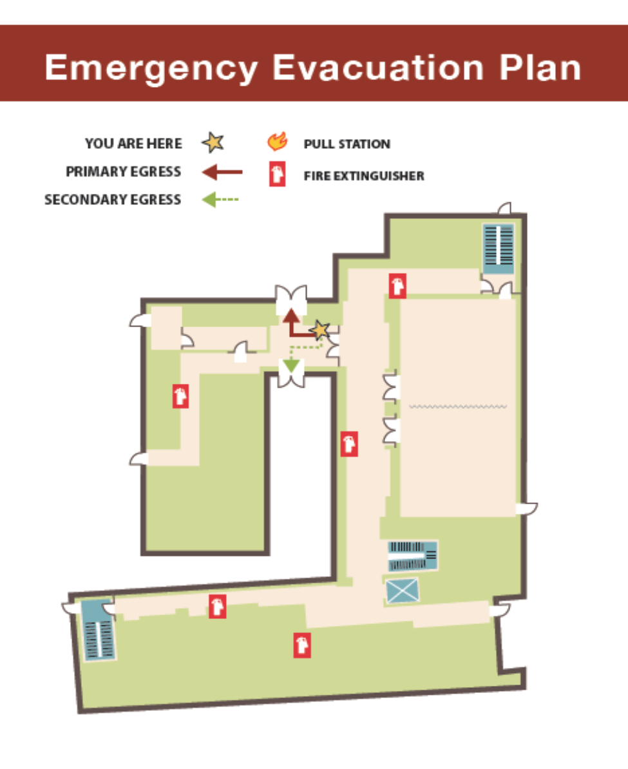

MARGARET H. ROLLINS SCHOOL OF NURSING

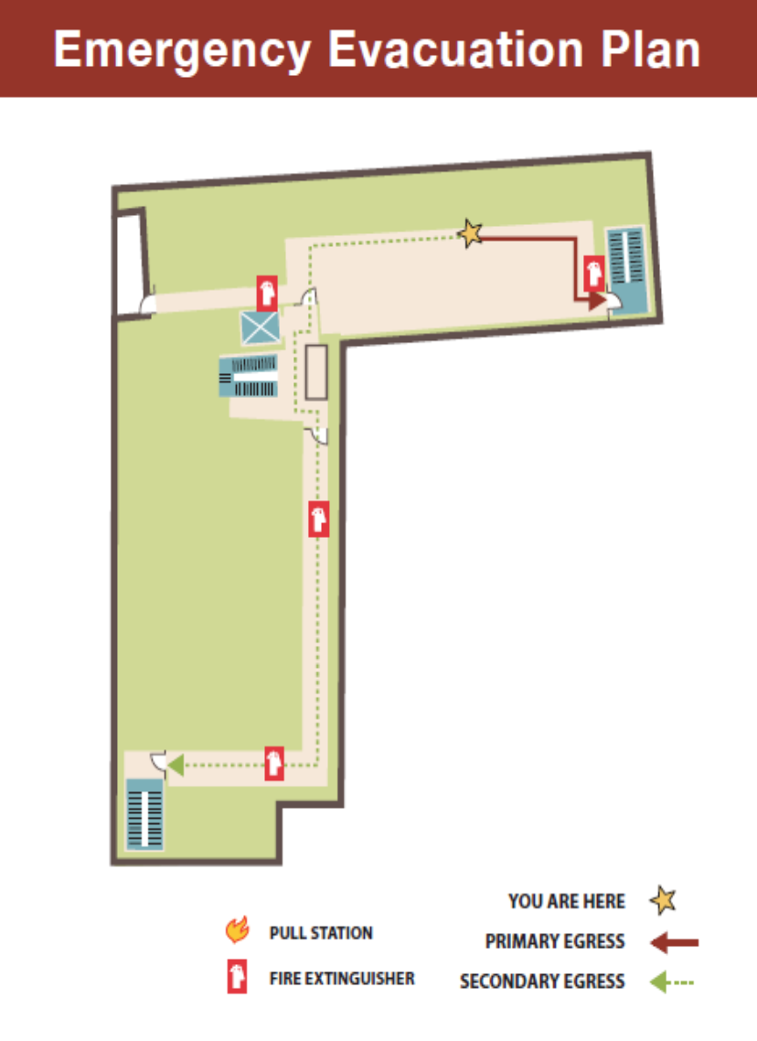
Second Floor

MARGARET H. ROLLINS SCHOOL OF NURSING
Third Floor

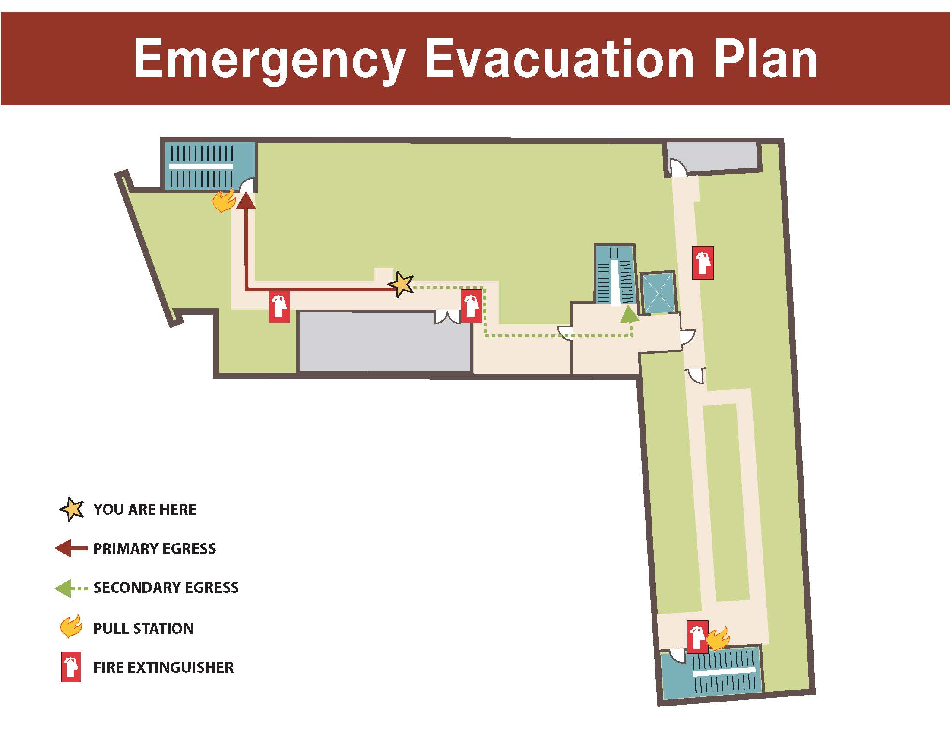

information security - cybersecurity

Student information is protected by Beebe Healthcare’s Information Technology (IT) Security Network Team. Information related to network security is presented to first-year students during orientation each year. Students are also required to complete mandatory education relevant to cybersecurity. All Beebe Healthcare policies related to computer access and network security pertain to team members, as well as students. Internal and external security assessments are performed according to the Security Assessments policy in order to reduce and/ or mitigate any risks. The designated IT Security Official for Beebe Healthcare and the Margaret H. Rollins School of Nursing is Robert Bentley, IT Security Manager, (302) 645-3100, ext. 5431.

Beebe Healthcare
Margaret H. Rollins School of Nursing
Academic & Administrative Policy
security assessments

Value: Each person is responsible for his or her actions, and individually accountable for satisfied patients and customers, confidentiality of patient and hospital information, quality outcomes, efficient operations, continued education and development, and the overall success of Beebe Healthcare.

Scope: Covered under this policy: Beebe Healthcare (Beebe) team members, all levels of management staff, contract personnel, members of the Beebe Auxiliary, volunteers, students, visiting clergy, associated medical staff, contracted vendors, and any other individual that accesses Beebe’s electronic systems.

Objective: The Health Insurance Portability and Privacy Act (HIPAA) Security Rule (§164.308(a)(1)(ii)(D)) requires covered entities to implement procedures to regular review records of information system activity, such as audit logs, access reports, and security incident tracking reports. The HIPAA Security Rule (§164.308(6)(i)/(ii)) require covered entities to implement policies and procedures to address security incidents, and to identify and respond to suspected or known security incidents; mitigate, to the extent practicable, harmful effects of security incidents that are known to the covered entity or business associate; and document security incidents and their outcomes. The purpose of this policy is to establish the audit, investigation, and proactive access audit procedures implemented by Beebe.

Definitions:
Ad-Hoc: Reports, assessments, or investigations that are performed for a singular or particular purpose, such as through requests by leadership, executive staff, or Human Resources.

Designated Security Official: HIPAA requires that an organization have a designated security official who has a clear responsibility for overseeing the organization’s information security systems, policies, and procedures.

Electronic Protected Health Information (ePHI): Any individually identifiable health information collected, transmitted, or stored in an electronic format.

HIPAA: Health Insurance Portability and Accountability Act of 1996: includes Transaction and Code Sets Rule, Privacy Rule, and Security Rule.

Risk: A measurement of the likelihood of an event occurring compared to the impact that event would have on a person, system, or organization. Beebe follows industry recommendations for risk assessments, including NIST SP800-30’s assessment scale risk matrix

Role-Based Access: The restriction of accesses and uses of protected health information based on specific professional and non-professional roles of our team members. This involves job category by job category analysis, which HIPAA refers to as “role-based access.”

Use of Protected Health Information: “Use” refers to Beebe’s internal utilization of PHI which includes the viewing, sharing, application, utilization, examination, or analysis of such patient information within the organization.

Policy: In accordance with the HIPAA statute, Beebe Healthcare recognizes their responsibility to implement Security Assessments appropriate to Beebe’s business practices and workforce in order to evaluate and maintain appropriate role-based accesses and to ensure compliance with established Beebe policies.

In order to protect and safeguard patients’ and team members’ confidential health information, Beebe recognizes its responsibility to conduct accurate and thorough assessments of the potential risks and vulnerabilities to the confidentiality, integrity, and availability of health information and to evaluate, implement, review, and revise security measures to sufficiently reduce or mitigate risks to an acceptable level.

A. Policy Directives
1. Internal Risk Assessments: The Designated Security Official, Security Analyst, and/or designees
shall perform the following activities which include, but are not limited to:

- Analyzing email content to ensure that encryption mechanisms are being utilized properly such that no confidential information leaves the organization without first being encrypted;
- Coordinating with Network Administrators and applicable staff to ensure that any spam, malware, questionable, or dangerous websites are quarantined or otherwise inaccessible to team members;
- Coordinate with the Corporate Compliance department for ad-hoc investigations that may be required by patient, leadership, or other authorized and appropriate requests;
- Perform physical walk-throughs on Beebe campus department locations to ensure that team members follow appropriate policies for locking workstations when unattended, that ePHI is not viewable from unauthorized or inappropriate individuals, and that no equipment, system, or technology is being inappropriately used;
- Perform regular system audits to ensure role-based access is appropriate and that team member unique user IDs are created and terminated in a timely fashion;
- Perform social engineering events, including email phishing attempts, physical shadowing, phone phishing, or any other event in attempt to evaluate administrative, technical, or physical gaps in organizational security;
- Regularly review the System Access Matrix and employee database to ensure there are no gaps in unique user ID creation, transfer, and/or termination; and
- Regularly review system logs for supporting and applicable systems to evaluate any inappropriate or unauthorized attempts to access an account or system (i.e., DDOS attacks, brute force password
attempts, or excessive use or login failures).

Any and all of these assessments will be documented in an appropriate manner, whether in a secure network folder or via Track-IT ticket to ensure accuracy and accountability. These assessments may be communicated to appropriate leadership and executive staff team members for further risk consideration and mitigation efforts, or for disciplinary action.

2. External Risk Assessments: The Designated Security Official will coordinate with a third-party contractor or vendor to evaluate the policies, procedures, actions, and activities performed within Beebe Healthcare and associate satellite offices. The External Risk Assessment will be performed at the discretion of the Designed Security Official, CIO, or executive or board decision. The contractor or vendor shall provide an objective and impartial review to assist with Beebe’s risk mitigation planning efforts.

3. Risk and Gap Evaluation: Beebe will conduct a risk and gap evaluation based on internal and external risk analysis results. In any instance where a gap is identified, the Designated Security Official and/or designee will assess the likelihood compared to the impact of the gap, following the National Institute of Standards and Technology (NIST) guidelines (SP 800-30) and as documented in Figure 1.

Likelihood (Threat Event Occurs and Results in Adverse Impact) | Impact
 | Very Low | Low | Moderate | High | Very High
Very High | Very Low | Low | Moderate | High | Very High
High | Very Low | Low | Moderate | High | Very High
Moderate | Very Low | Low | Moderate | Moderate | High
Low | Very Low | Low | Low | Low | Moderate
Very Low | Very Low | Very Low | Very Low | Low | Low
Figure 1

The likelihood and impact are evaluated through a sliding rank scale. Likelihood denotes the possibility that the risk or gap will result in an adverse or unwanted consequence which may denote a failing within a policy, procedure, or HIPAA specification. Impact refers to the severity of consequences should a risk be actualized. A breakdown of likelihood and impact is as follows:

Likelihood | Description
Very Low | Unlikely to occur
Low | Will not occur in the short term, and only possibly in long-term
Moderate | Unsure if it will ever happen, but reasonable to assume it could
High | Likely to happen, but could be a year or more away
Very High | Very likely to occur within short-term

Impact | Description
Very Low | Almost no impact or damage to Operations or the Individual
Low | Minor damage to Operations, no adverse effect on Individual
Moderate | Impacts Operations and effects the Individual
High | Substantial damage or disruption to Operations, or the Individual
Very High | Harm, disruption, or damage to Operations and Individual with recovery requiring a significant effort

a. Risk Ranking: Each gap or risk must be thoroughly evaluated and appropriately ranked, and also include a proposed mitigation solution.

b. Mitigation Solution: Each gap or risk must include, where applicable, a mitigation strategy, solution, or action plan that will result in the risk being transferred, mitigated, lessened, or accepted. The resultant mitigation solution may be provided to the VP of Information Services / CIO, the HIPAA Security Committee, or any other member of leadership or executive staff for additional financial, reputational, or operational considerations.

Procedure:

A. Policy Review and Revision:
a. Information Services policies and procedures shall be reviewed no less than annually to ensure the accuracy and validity of all contents.
i. Policies and procedures may be reviewed and revised more frequently based on changes to systems, operations, support, staff, state and federal regulations, or any other appropriate change.
b. Policies may be revised with recommendations from the HIPAA Security Committee or any other appropriate member of Information Services or affiliated or effected department designee.

B. Email Analysis:
a. Appropriate use of email shall be regularly evaluated based on system capabilities which includes, but is not limited to:
i. Monthly emails that were purposefully encrypted;
ii. Monthly emails that were encrypted due to the inclusion of sensitive or confidential keywords; and,
iii. Occurrences of spam, malware, phishing, or malicious content.
b. Any anomalies to regular analysis shall be evaluated via the Risk and Gap Evaluation criteria specified in Section 3 of this policy.
c. Individuals found to be violating Beebe’s policies for Appropriate Use, Access Control, Portable Electronic Device, or other applicable policies shall be reported to the VP of Information Services / CIO and the Human Resources department for disciplinary actions.

C. Malware Analysis:
a. The Designated Security Official, Security Analysts, and/or appropriate designee shall regularly document and report any instances of spam, malware, or any other questionable or malicious website or email through a Track-IT ticket, or via a spreadsheet maintained on a secure network location.

D. Corporate Compliance Requests:
a. The Designated Security Official, Security Analysts, and/or appropriate designee may be required to assist or coordinate with ad-hoc investigations, audits, or other reports based on system activity, system accesses, or appropriate use. Any reports as a result of investigation or audit shall be documented in a secure network location.

E. Physical Walkthroughs:
a. The Designated Security Official, Security Analysts, and/or appropriate designee will perform physical walk-throughs on Beebe campus department locations a minimum of quarterly. Physical assessments will examine the security of computer workstations, mobile devices, visibility of any confidential, private, or security information, as well as any other equipment, devices, or locations which could be considered a violation of Beebe’s applicable security, privacy, or compliance policy.

F. System Audits:
a. The Designated security Official, Security Analysts, System Administrators, and/or appropriate designee will perform regular server, system, and application audits. These audits will include, but are not limited to:
i. Evaluating user accounts for accuracy based on role and requirement as per the Security Access Matrix and employee database, including:
1. Accounts that are deemed inappropriate will be verified as inappropriate with the system owner, department manager or director, Human Resources, or any other applicable authorized party.
2. Accounts that are confirmed as inappropriate will be documented within Track-IT and may be disabled, deleted, or terminated to ensure accuracy and security.

ii. Examining the last known login of a user to a system, server, or device.
1. Accounts that exceed an idle or used timeframe for 180 days may be disabled, deleted, or terminated.

iii. Analyzing system, server, or device logs for potentially malicious behavior, including:
1. Multiple failed logins;
2. Concurrent logins from multiple devices; and,
3. Accounts being granted elevated or administrator-level permissions

b. Any and all audits performed will be documented and stored electronically either in a secure network location, or within Track-IT.

G. Social Engineering:

a. The Designated Security Official, Security Analysts, and/or other appropriate designee will regularly perform social engineering events to test the efficacy of security measures as well as security awareness and training. Social Engineering opportunities include, but is not limited to:
i. Email phishing attempts;
ii. Physical shadowing or “piggybacking”;
iii. Phone phishing; and,
iv. Any other activity to evaluate administrative, technical, or physical gaps in organizational security.

b. Social Engineering activities will receive verbal or written confirmation first from the VP of Information Services / CIO prior to any engagement.

c. Upon approval, social engineering tests will be run in such a manner as to limit the functional impact such tests may have on daily operations.

d. The results of any social engineering test will be fully documented and stored in a security network location.
i. The results will be provided to the VP of Information Services / CIO, as well as any other member of leadership or management that is deemed appropriate.
ii. The results may be used to augment, supplement, or otherwise improve security awareness and training events in an effort to increase team member knowledge of security and to prevent reoccurrence.

Beebe Healthcare
Margaret H. Rollins School of Nursing
Academic & Administrative Policy

Sexual Harassment & Other Forms of Harassment

Value: Respect for the Individual. Beebe Healthcare acknowledges their commitment to provide high-quality, cost-effective health care to their patients, respecting each patient’s rights as an individual and embracing the cultural diversity of our patients and their families. We treat everyone with dignity and respect. This includes patients, visitors, guest, employees, physicians, volunteers, vendors, and all others with whom we come in personal contact.

Policy: It is the policy of Beebe Healthcare/School of Nursing to treat all team members/students with dignity and respect and to provide a work/educational environment free from harassment and illegal discrimination based on race, national origin, color, religion, age, disability, gender (including pregnancy), sexual orientation, veteran status, genetic information or any other factor protected by federal, state or local law. No team member/student should be subjected to harassment or discrimination by another team member, manager, client or visitor and all team members should be aware of what harassment, both sexual and non-sexual, and discrimination are and what steps to take if harassment or discrimination occurs. This policy not only applies to team members/students but also to organizations with whom we have business relationships and others functioning under the medical center’s control.

Discrimination in General:
Discrimination includes unfavorable treatment of an individual with regard to employment actions such as hiring, promotion, termination, compensation, and other terms and conditions of employment/education based on race, national origin, color, religion, age, disability, gender (including pregnancy), sexual orientation, veterans status, genetic information or any other factor protected by federal, state or local law.

Harassment in General:
Harassment includes behavior that demonstrates hostility toward another individual based on race, national origin, color, religion, age, disability, gender (including pregnancy), sexual orientation, veteran status, genetic information or any other factor protected by federal, state or local law. The behavior may constitute harassment when it unreasonably disrupts or interferes with a person’s work performance/education or creates an intimidating, hostile or offensive work environment. Harassing conduct may include, but is not limited to: epithets, slurs or negative stereotyping; threatening, intimidating or hostile acts, denigrating jokes; and written or
graphic materials that denigrate or show hostility or aversion toward an individual or group and that is placed on the employer’s premises or circulated in the workplace.

Sexual Harassment:
Sexual harassment includes unwelcome sexual advances, requests for sexual favors and
other conduct of a sexual nature, or conduct based on an individual’s gender where:
1) Submission to such conduct is made a term or condition of an individual’s
employment, either explicitly or implicitly,
2) Submission to or rejection of such conduct is used as the basis for decisions affecting an individual’s employment, or
3) Such conduct unreasonably interferes with an individual’s work performance/education or has the effect of creating an intimidating, hostile or offensive working environment. Sexual harassment may include a range of subtle and not-so-subtle behaviors and may involve individuals of the same or different gender. These behaviors may include, but are not limited to: unwanted and unwelcome sexual advances or requests for sexual favors; sexual jokes and innuendo; verbal abuse of a sexual nature; leering, whistling or touching; insulting or obscene comments or gestures; display in the workplace of sexually suggestive objects or pictures; other physical, verbal or visual conduct of a sexual nature; or conduct based on an individual’s gender.

Complaint Procedure
Beebe Healthcare/School of Nursing encourages individuals who believe they are being subjected to harassment or discrimination to address the issue, regardless of the alleged offender’s identity or position. Beebe Healthcare has established the following procedure to facilitate the investigation and resolution of claims of harassment or discrimination:
1) If possible, the team member/student affected should politely but firmly advise the offender that his or her behavior is unwelcome and request that it stop immediately. The individual may not realize that his or her behavior is offensive and often this action alone will end the unwelcome advances or behavior. It is not necessary for a team member/student to speak directly to the offender if he or she feels uncomfortable or believes that negative consequences may result.
2) If for any reason a team member/student does not wish to address the offender directly, or if such action does not end the offensive conduct, the team member/student should notify the School of Nursing Program Administrator, or any member of the Human Resources Department.
3) Any complaint of harassment or discrimination received by any member of management must be reported to Human Resources Management.
4) The team member making the report must report to the Director of Employment
& Organizational Development.

Document/form that may be used to document a complaint.

Claims of harassment or discrimination will be investigated by the School of Nursing Program Administrator or designee promptly. Confidentiality will be maintained throughout the investigative process to the extent consistent with adequate investigation and appropriate corrective action.

Retaliation against any team member/student who opposes harassment or discrimination, files a complaint, testifies or participates in an investigation of a claim of harassment or
discrimination is prohibited and will be subject to disciplinary action. Acts of retaliation
should be reported immediately.

While it is not the purpose of this policy to regulate a team member’s/student’s personal morality, we consider harassment, discrimination or retaliation to be an act of misconduct and subject to appropriate disciplinary action, up to and including termination of
employment. False and malicious complaints of harassment, discrimination or retaliation
may be the subject of appropriate disciplinary action. On the other hand, a team member/student will not be disciplined merely because the complaint is found to be without merit. Beebe Healthcare/School of Nursing does not condone retaliation against any team member/student for making a report in good faith under this Policy.

Team/Student Member filling out Report: ________________________________

Alleged Offender Name: ___________________________ Dept/Ext.__________

Witnesses: ______________________________________ Dept/Ext.__________
Event(s):
(Use additional sheets of paper if required)

You should be aware that the nature of your complaint may require Beebe Healthcare/School of Nursing to investigate it, even if you request otherwise. Should you wish Beebe Healthcare/School of Nursing not to disclose certain information you have provided, please specify that information below. Beebe Healthcare/School of Nursing will try to honor such requests consistent with its obligation to identify and correct instances of harassment, including sexual harassment. Confidentiality may not always be possible because of the steps necessary to eliminate the harassment.
________________________________________________________________________________________________________________________________________________________________________________________________________________________________________________________________________________________________________________________________________________________________________________________________________________________________________________________________________________________________________________________
____________________________ __________________
Signature of team member/student Date

Beebe Healthcare
Margaret H. Rollins School of Nursing
Academic & Administrative Policy
Drug & Alcohol

Value: Respect for the Individual. Beebe Healthcare acknowledges their commitment to provide high-quality, cost-effective health care to their patients, respecting each patient’s rights as an individual and embracing the cultural diversity of our patients and their families. We treat everyone with dignity and respect. This includes patients, visitors, guest, employees, physicians, volunteers, vendors, and all others with whom we come in personal contact.

POLICY: It is the intent of the Margaret H. Rollins School of Nursing to provide an educational environment that is safe, healthy and productive for all students. Educational materials on the health risks associated with the use of illicit drugs and the abuse of alcohol are provided on the student bulletin boards. In order to do this, students must be drug/alcohol-free. It is the policy of the School of Nursing that the possession, use, consumption, sale, purchase, or distribution of illegal drugs, or any illegally-obtained drugs on Beebe Healthcare property or within its facilities, in the conduct of the School of Nursing responsibilities (including lunch time and breaks), is strictly prohibited and will be grounds for immediate dismissal. In addition, the School of Nursing does not permit any student to report for school responsibilities after having used illegal drugs or while under the influence of alcohol. The School of Nursing does not permit any student to report for school responsibilities while taking prescribed drugs or over-the-counter drugs that adversely affect the student’s ability to effectively perform his or her responsibilities. Students are required to notify Employee Health of all therapeutic use of controlled substances. The Beebe Healthcare Employee Health Nurse and/or student’s physician will determine if the student can safely carry out their responsibilities. Marijuana in any form must be

approved by your physician and the employee must be issued a State of Delaware medical marijuana state identification card. Any team member with a state-issued medical marijuana identification card must present this card to Employee Health upon issue. Additionally, this card must be updated every 12 months and the new card presented to Employee Health. A drug free workplace/educational facility will require all students to submit a urine specimen for the purpose of drug testing prior to enrollment and annually. The School of Nursing will test students under the following conditions:
- Prior to enrollment in First Year Nursing at a time designated by the School of Nursing.
- On an annual basis, prior to and/or at the beginning of the Senior Year at a time designated by the School of Nursing.
- Random drug screening will be conducted on a minimum of 25% of the student body during the school year (see Attachment Four for procedure).
- When the School of Nursing has reason to believe, based on observation or reliable information, that a student has been using, or is under the influence of alcohol or drugs, other than authorized and reported prescription drugs, the student will be asked to submit to a urine drug test and/or a blood alcohol test.

Refusal to submit to a test under any of the above conditions will result in dismissal from the program.

A School of Nursing student must notify the School of Nursing in writing of his/ her conviction for a violation of a criminal drug statue within five calendar days of the conviction.

Inspections and Searches

Beebe Healthcare/the School of Nursing respects the privacy of individuals. However, in cases where Beebe Healthcare/the School of Nursing has reasonable suspicion to believe that a student may be in possession of alcohol, drugs or drug paraphernalia on Medical Center property, the School of Nursing administration and Beebe Healthcare Security Officers reserve the option to inspect personal property. A student may be requested to empty the contents of his/her personal effects (such as lunch boxes, handbags, outer clothing, etc.). Personal vehicles on Medical Center property are also subject to search. Such inspections may be requested and performed by the School of Nursing administrator with a Human Resources Manager or his/her designee, and whenever reasonably possible the student involved will be present during the inspection.

Procedure:
In accordance with the intent of this policy, the following procedure will be used:

- All accepted students will be scheduled with the Employee Health staff for the purpose of being tested for drugs. Drug specimens will be sent to an outside reference lab for testing. Results must be negative in order to continue with enrollment in the School of Nursing and will be kept in confidence. The dates the sample was collected and results will be shared with a representative from the School of Nursing for the Criminal Background check Center documentation.

- If a student exhibits behavior that is suspicious of drug/alcohol use when on school responsibilities, the student’s instructor will notify the School of Nursing Program Coordinator and Employee Health staff or Vice President of Human Resources immediately. The instructor will use the Instructor’s Observation Form (see Attachment One) to document behavior observed, confront the student in question, and accompany them to the Employee Health Office.

- The School of Nursing staff will review the School of Nursing’s Drug/Alcohol policy with each student to be tested for probable cause and ask the student to submit to a drug/alcohol test. Students are expected to cooperate fully in providing witnessed specimens and explanations that may be subsequently required by this policy. Students submitting to the drug/alcohol test will be required to sign the Informed Consent and Release of Liability Form (see Attachment Two). Attempts to contaminate specimens or otherwise interfere with policy procedures will be grounds for immediate dismissal.

- If the student refuses the test for probable cause, he/she will be asked to sign the Refusal to Submit to Drug/Alcohol Testing (see Attachment Three) and will be dismissed from the School of Nursing.

- If the student agrees to the drug/alcohol test, the specimen will be obtained by Beebe Healthcare Employee Health staff trained in the procedure for collecting and submitting drug/alcohol specimens. All testing will be conducted by a Beebe Healthcare designated, certified medical testing laboratory with appropriate chain of custody procedures in place to ensure accuracy and continuity in specimen collection, handling, transfer and storage.

- If the student is being tested for cause, following the administration of a drug/alcohol test, the student will be driven home by the school of nursing personnel or other designated individual and will be suspended. If the drug/alcohol test is negative, the student will be able to return to school responsibilities, and assignment will be discussed with the Course Coordinator/School of Nursing Program Administrator for the originally scheduled hours that the student was suspended.

- All specimens identified as positive on the initial test are verified by a confirmatory test. In the event of a positive test, the student may request independent testing, at her/his own expense, paid at time of request, of a portion of the tested specimen for verification of the test results. If the independent test result is negative, Beebe Healthcare will re-test the original sample.

- Any student whose test results are confirmed positive will be dismissed and advised to seek professional assistance immediately (see the section on Substance Use Treatment and Rehabilitation Services that follows). Students who do so may request readmission according to the School of Nursing Readmission Policy.

Federal and State of Delaware Laws for Violations of Alcohol and Drugs

Federal and the State of Delaware laws prohibit the manufacture, distribution, or dispensing, or possession with intent to manufacture, distribute, or dispense, controlled substance. Information regarding the federal laws for controlled substances is available on the U.S. Department of Justice Drug Enforcement Administration Diversion Control Division website https://www.deadiversion.usdoj.gov/21cfr/21usc/844.htm.
Information regarding the State of Delaware laws is available on the State of Delaware website http://www.delcode.delaware.gov/title16/c047/sc04/index.shtml

Substance Use Treatment and Rehabilitation Services

Should a student realize that he or she has developed a dependence on drugs, alcohol or any controlled substance, he or she is advised to inform his or her instructor and/or the Program Coordinator to seek trained, professional assistance immediately. Cost for treatment and rehabilitation will be the responsibility of the student. Students are encouraged to come forward voluntarily (without disciplinary penalty), prior to any management action, to address and resolve any drug and/or alcohol-related problems on a confidential basis. At the time of seeking outpatient assistance or if in-patient treatment is necessary, the student may be advised to take a leave of absence according to the School of Nursing Leave of Absence Policy if unable to meet the attendance requirement of the school based on the School of Nursing Attendance Policy.

Beebe Healthcare
WORKPLACE VIOLENCE PREVENTION POLICY

PURPOSE

The safety and security of personnel, patients, and visitors is of vital importance. Therefore, acts of violence and threatening behavior (threats of acts of violence) will not be tolerated. We are committed to providing a competent workforce that is safe and can ensure safe, quality care for our patients.

SCOPE

All Beebe Healthcare staff, vendors, and contractors have a responsibility of maintaining a safe and secured environment by reporting all workplace violence incidents. Beebe Healthcare includes all facilities where Beebe Healthcare operates, all Beebe Medical Group facilities, and the Beebe Healthcare Foundation.

DEFINITIONS
Workplace Violence:
- The CDC National Institute for Occupational Safety and Health (NIOSH) definition: violent acts
(including physical assaults and threats of assaults) directed toward persons at work or on duty.
- The U.S. Department of Labor definition: an action (verbal, written, or physical aggression) which is intended to control or cause, or is capable of causing death or serious bodily injury to oneself or others, or damage to property.
Types of Violence:
- Criminal Intent: perpetrator has no legitimate relationship to the business or its employees, and is usually committing a crime in conjunction with the violence (robbery, shoplifting, trespassing).
- Customer/Client: the most common in healthcare settings. Customer/client relationship includes patients, their family members, and visitors.
- Worker on Worker: violence between coworkers is commonly referred to as lateral or horizontal violence. It includes bullying, and frequently manifests as verbal and emotional abuse that is offensive, vindictive, and/or humiliating.
- Personal Relationship: the perpetrator has a relationship to a team member outside of work that spills over to the work environment. For example, the husband of a nurse follows her to work, orders her home and threatens her.

POLICY

Beebe Healthcare will not tolerate threats of violence or acts of verbal or physical violence against patients, visitors, medical staff, team members, or volunteers. This policy describes the actions to take to prevent aggressive behavior and the actions to take in response to aggressive behavior and violence that team members may experience. It also describes steps to take to report a threat or act of violence.

Violence Prevention Program Elements:

1. Conducting an annual assessment which includes facility layouts, access control, lighting, crime in the surrounding community, communication equipment, emergency response capabilities, and a review of incidents at facilities.

2. Controlling access to facilities and sensitive areas:
a. Ensuring adequate security systems including card readers, cameras, door locks, windows, and physical barriers are operational and appropriate for the setting.
b. Maintaining effective systems to warn others of a security danger or to summon assistance (i.e., panic buttons).
c. Providing adequately trained Public Safety and Security staff to provide services and response.

3. Establishing a Workplace Violence Prevention Committee to be responsible for the Workplace Violence Prevention Program
a. The Workplace Violence Prevention Committee will review data related to verbal and physical assault incidents and identify trends involving workplace violence.
b. The Committee will recommend specific methods to reduce identified risks, including training, and changes to job design, staffing, security, equipment, and facility modifications.

4. Enforcing Visitor Access Control and identification policies.

5. Ensuring that staff complete appropriate training and education:
a. Managers and Directors are to ensure that staff complete:
i. Education which includes information about workplace violence, Active Shooter and department-specific training as appropriate
ii. Completion of CPI (Crisis Prevention Institute) de-escalation training annually for those departments that are designated as requiring training.

PROCEDURE

- Any incident, conduct, or circumstances that raise concern about possible violence can and should be reported by any team member within Beebe Healthcare. The report should be made to the Department of Public Safety and Security (“DPSS”).

- The incident will be investigated by DPSS in conjunction with leaders of the area where the incident occurred. Violations of this policy by any individual are considered misconduct and will lead to appropriate action which may include disciplinary and/or legal action.

- No reprisals will be taken against any team member who reports or experiences workplace violence.

- DPSS will notify the appropriate law enforcement agency when applicable. DPSS team members will work cooperatively with law enforcement to provide information about the threat or act of violence.

- Beebe Healthcare or any team member may file criminal charges to initiate prosecution of an individual who has threatened violence or committed an act of violence.

- Any threat or act of violence by a team member should be reported to the Director/Manager and the Public Safety and Security Department immediately. If a Beebe Healthcare team member threatens violence or performs an act of violence, disciplinary action up to and including termination, may occur. This may include termination for a first offense.
NOTE: If a person believes they are a victim of harassment (rather than workplace violence) by another team member, they are to follow the steps outlined in the policy: Sexual Harassment and Other Forms of Harassment, found in the Human Resources Manual. If a person is experiencing episodes of intimidation, negative stereotyping, slurs, denigrating jokes and other disrespectful behavior from a Beebe team member, steps noted in the Human Resources policy above include (1) politely but firmly advising the offending team member that the behavior is unwelcome and request it stop immediately; (2) If the team member does not wish to address the offender directly, or the request to stop the behavior does not end the offensive conduct, then team member should notify his/her Director/Manager or any member of the Human Resources Department.

7. The possession of a handgun or any other type of weapon by any patient, visitor, vendor, contractor, student, visitor, or team members on Beebe Healthcare property is prohibited. The only persons permitted to carry weapons are Beebe’s Department of Public Safety and Security Officers and active duty law enforcement officers.

8. If a team member has been assaulted (person makes physical contact with the team member or exposed the team member to blood and/or body fluids), that team member is to (1) notify Employee Health and (2) complete a “Report a Safety Observations” report using the Global HR/Employee Manager Space software.

NOTE: All physical contact events are to be reported to Employee Health, even if the team member
does not believe he or she has sustained an injury from the physical contact.

IMMEDIATE RESPONSE TO POTENTIAL OR ACTUAL VIOLENCE:

• Any threat or act of violence made by a patient, visitor, team member/employee, former patient, or any other individual needs to be reported immediately to the Department of Public Safety and Security. If the threat involves a patient, notify the BERT (Behavioral Emergency Response Team) by calling DPSS at extension 3-3-3-3 and request a BERT. NOTE: for satellites and BMG locations, report to the Police by calling 911 with a later report to Beebe’s Public Safety and Security when appropriate/after Police response.

• The Public Safety and Security Department will notify the appropriate law enforcement agency when applicable. Beebe Healthcare’s Public Safety and Security team members will work cooperatively with law enforcement to provide information about the threat or act of violence.

STEPS TO PREVENT POTENTIAL ACTS OF VIOLENCE:

- Review past incidents of aggression or violence involving the patient, family, visitor, and/or team member.
- Refer to the “Warning Signs and recommended Appropriate Response to Aggressive Behavior Guidelines for Guidance” within this policy.
- Develop a plan:
  - A plan to manage the patient’s behavior and care needs to occur. Involve the Behavioral Health Nurse, Public Safety and Security, the patient’s physician, as well as managers and directors as appropriate.
  - A plan to manage a visitor or family member’s behavior needs to occur. Best efforts to place appropriate limitations should occur with the last resort being non-visitation with the patient or asking the visitor or family member to leave Beebe premises. Involve the Behavioral Health Nurse, Public Safety and Security, the patient’s physician (if applicable) as well as managers and directors as appropriate.
- Identify victims/potential victims and offer additional security measures (such as: escorts; worksite, shift, or patient re-assignment; assistance in obtaining restraining orders, etc.) or team member assistance programs.
- Ensure adequate security presence and response is available (additional staff, escorts, patrols, special assignments).
- Establish liaison with local law enforcement and emergency services to obtain restraining orders, file trespass or criminal charges or develop strategies for outside the work environment if applicable.
- Make use of available communication mechanisms so that all team members who may provide care for an escalating or potentially aggressive, abusive or violent patient will be aware of the patient’s status and of any problems experienced in the past.
- Communicate the potential threat and action plans to team members or others that were or may be involved through hand-off communication.
- Investigate: Public Safety & Security and/or Human Resources will investigate the workplace violence incident.

POST INCIDENT MANAGEMENT:

- No team member will be disciplined or terminated for reporting any threats or acts of violence.
- Victims of violence will receive immediate physical evaluations and treatment for acute injuries.
- Additionally, referrals shall be made for appropriate evaluation, treatment, counseling and assistance both at the time of the incident and for any follow-up treatment necessary.

RECORD KEEPING:

• Employee Health: Record keeping includes the following: A Safety Observation will be completed and a first report of injury will be filed, if appropriate, with the workers compensation carrier. Additional year end reporting will be complete for all recordable injuries.

• The Patient Record: Documentation of incident and behavior should be recorded by team members using a Significant Event in Cerner or Nursing Note or Significant Event in IBEX or other appropriate area of the patient’s medical record. Document in quotations exactly what the patient said and describe their actions factually. If at a satellite location or BMG, the documentation should be recorded in the EMR that is being used.

• Safety Tracking Tool (“STT”): Team members need to complete a STT for any acts of violence or threats of violence. If the event involves a patient, documentation of the facts of what occurred should mirror what is documented in the patient’s EMR. It is very important that the events are documented both in the patient chart and in the STT. If the event involved a visitor, student, team member/co- worker, and the like, documentation is to occur via STT.

REFERENCES

1. Joint Commission Sentinel Event Alert #59 Physical and verbal violence against health care workers,
April, 2018

2. Crisis Prevention Institute. CPI’s Top 10 De-Escalation Tips, 2016

3. ECRI Institute: Patient Violence. Healthcare Risk Control, July 2013

4. ECRI Institute: Violence in Healthcare Facilities, Healthcare Risk Control, May 2017

5. Crisis Prevention Institute (CPI): The Art of Setting Limits, 2009

6. Partridge, B & Affleck, J. (2018). Predicting aggressive patient behaviour in a hospital emergency department: An empirical study of security officers using the Brøset Violence Checklist. Australasian emergency care, 21(1), 31-35. doi:10.1016/j.auec.2017.11.001

7. OSHA Workplace Violence at: https://www.osha.gov/SLTC/workplaceviolence/ February 2019

8. OSHA Guidelines for Preventing Workplace Violence for Healthcare and Social Service Workers www.osha.gov 2015

9. GAO United States Government Accountability Office Report to Congressional Requesters, Workplace Safety and Health; Additional Efforts Needed to Help Protect Health Care Workers from Workplace Violence, March 2016

10. Oregon Workplace Safety Initiative, Stop Violence in Healthcare; Workplace Violence in Hospitals, a Toolkit for Prevention and Management, Oregon Association of Hospitals Research and Education Foundation, December 2017 (endorsed by The Joint Commission in August 2018)

Warning Signs and the Recommended Appropriate Response Guidelines to Aggressive Behavior

The following is a guideline for determining the severity of a violent situation and the appropriate response:
Definition | These are behaviors that should raise the awareness of the team members and others around the team member, patient or visitor. If the person is exhibiting any one of the behaviors below (in BOLD) call 3333 and ask for the BERT Team (BERT = Behavioral Emergency Response Team) OR SATELLITES CALL 911.  Please notify the BERT Team anytime you feel that any of the other Behavioral Examples below are escalating.
Behavioral  Examples | Boisterous: behavior is overtly “loud” or noisy. For example slams doors, shouts out when talking, etc.  Irritable: easily annoyed or angered. Unable to tolerate the presence of others.  Showing increased body tension  Refuses simple requests or makes demands  Sexual comments, gestures, or innuendo  Verbally threatening: A verbal outburst which is more than just a raised  voice; and where there is a definite intent to intimidate or threaten another  person. For example verbal attacks, abuse, name-calling, verbally neutral  comments uttered in a snarling aggressive manner.  Making unreasonable requests of staff  Possessing a weapon or suspicion that they have a weapon (call Dept. Public Safety & Security)  Confusion: Appears obviously confused and disoriented. May be unaware of time, place or person  Physically threatening: Where there is a definite intent to physically threaten another person. For example the taking of aggressive stance: the grabbing of another person’s clothing; the raising of an arm, leg, making of a fist or modeling or a head-butt directed at another.  Attacking objects: an attack directed at an object and not an individual. For example the indiscriminate throwing of an object: banging or smashing windows; kicking, banging or head butting an object; or smashing of furniture.  Attempts to instigate fights  Belief that others are conspiring against them or prosecuting them  Sexual or violent notes sent to others  Expressed suicidal thoughts or threats  Comments about weapons or stories of harming others  Probable need for use of emergency measure of control, such as chemical (medications) or physical restraints (as last resort). Give patient opportunity to comply before using physical force-hands-on intervention should be a last resort

Showing a weapon
Sabotage with intent to harm others
Suicide attempt
Potential Responses you can take to the Behavioral Examples listed above | Call BHRT (Behavioral Health Response Team) or 911 if applicable  Follow 10 Tips to Crisis Prevention Skills.  Be prepared to alert other staff  Observe for potential weapons they might use  Look for underlying cause of anger  Do not use open ended question, give only a few choices  Set Limits  Redirecting tension towards appropriate problem-solving behavior  Have someone who has established a relationship talk with them  Offer food and drink (if appropriate); it has a calming effect and conveys caring  Try to move the person to a low-stimulus area  If the individual becomes belligerent, defensive or disruptive, state limits and directives clearly and concisely.  Request psychiatric consultation and 1:1 Observation for behavioral health/violence  (if applicable to situation)  Let the person know that violence will not be tolerated  Assess the need for use of emergency measure of control, such as chemical restraints (medications) or physical restraints (as last resort). Give patient opportunity to comply before using physical force: hands-on intervention should be a last resort  Press criminal charges for the person to be prosecuted (as applicable)

10 Tips for Crisis Prevention

- Be empathic/empathetic (show empathy for the person).
Try not to judge or discount the feelings of others. Whether or not you think their feelings are justified, those feelings are real to the other person. Pay attention to them.

- Clarify messages.
Listen for the person’s real message. What are the feelings behind the facts? Ask reflective questions and use both silence and restatements.

3. Respect personal space.
Stand at least 3 feet from an acting-out person. Invading personal space tends to increase the individual’s anxiety and may lead to acting-out behavior.

4. Be aware of your body position.
Standing eye-to-eye and toe-to-toe with a person in your care sends a challenging message. Standing one leg-length away and at an angle off to the side is less likely to escalate the individual.

5. Ignore challenging questions.
When a person in your charge challenges your authority or a facility policy, redirect the individual’s attention to the issue at hand. Answering challenging questions often results in a power struggle.

6. Permit verbal venting when possible.
Allow the individual to release as much energy as possible by venting verbally. If you cannot allow this, state directives and reasonable limits during lulls in the venting process.

7. Set and enforce reasonable limits.
If the person becomes belligerent, defensive, or disruptive, state limits and directives clearly and concisely. When setting limits, offer choices and consequences to the acting-out individual.

8. Keep your non-verbal cues non-threatening.
The more an individual loses control, the less that individual listens to your actual words. More attention is paid to your nonverbal communication. Be aware of your gestures, facial expressions, movements, and tone of voice.

9. Avoid overreacting.
Remain calm, rational, and professional. Your response will directly affect the person’s behavior.

10. Use physical techniques only as a last resort.
Use the least restrictive method of intervention possible. Physical techniques should be used only when individuals are a danger to themselves or others. Physical interventions should be used only by competent/trained staff. Any physical intervention may be dangerous.

CPI’s Five-Step Approach to Setting Limits
Definition | Setting a limit is not the same as issuing an ultimatum.  Limits aren’t threats—If you don’t go back to bed, we will tie you down  Limits offer choices with consequences—If you attend group and follow the other steps in your plan, you’ll be able to attend all of the special activities this weekend. If you don’t attend group, then you’ll have to stay behind. It’s your decision.
1. Explain which behavior is inappropriate | Saying “Stop that!” may not be enough. The person may not know if you are objecting to how loudly he is talking or objecting to the language that he is using. Be specific.
2. Explain why the behavior is inappropriate. | Again, don’t assume that the person knows why his/her behavior is not acceptable. Is he/she disturbing others? Being disrespectful? Not doing a task he/she has been assigned?
3. Give reasonable choices with consequences. | Instead of issuing an ultimatum (“Do this or else”), tell the person what his choices are, and what the consequences of those choices will be. Ultimatums often lead to power struggles because no one wants to be forced to do something. By providing choices with consequences, you are admitting that you cannot force his/her decision. But you can determine what the consequences for his/her choices will be.
4. Allow time. | Generally, it’s best to allow the person a few moments to make his/her decision. Remember that if he/she is upset, he/she may not be thinking clearly. It may take longer for him/her to think through what you’ve said to him/her.
5. Be prepared to enforce your consequences. | Limit setting is meaningless if you don’t consistently enforce the consequences you’ve set. For that reason, it’s important to set consequences that are reasonable, enforceable, within your authority, and within the policies and procedures of this organization.

